**Duty Terminal Stops**

***Work-flow to Use Duty Terminal Stops***

Use **Load Template** to set up the preference. Only one instance of this preference may be used. Two templates are available, one of which is an extension of the other.

***Preference Overview***

This preference deals with the stops in which a driver is allowed to start and end his duty and/or split break, and also with the usage of relief vehicles to transport the drivers to those stops. The user can choose whether the start and end stops would be in the same depot, or whether it would be in a list of specific stops.

***Templates Available from Optibus***

*Table 1-1: Templates Summary*

|  |  |  |
| --- | --- | --- |
| **Template Name** | **Purpose** | **Reference** |
| Duty terminal stops |  | **Duty terminal stops** |
| Relief Vehicles |  | **Relief Vehicles** |

***Duty terminal stops***

**Purpose:**

Sets up relief vehicle parameters. A relief vehicle may also be another fleet vehicle (as dis- tinct from a taxi or any other third part shuttle transport). Using a fleet vehicle as a relief vehicle, is a deadhead.

**Prerequisites:**

Setting the driver terminal/split stop group can be done in Expert mode. To do this, consult Optibus professional Services. This setting requires a pre-defined list of stop groups that are set under “Stop Groups” preference. Each stop group can be in the type of a single group or 2 sub-groups - "start" stops and "end" stops

Vehicle depot circularity should be enabled in the **Depot Vehicle Allocation** pref- erence.



**Opening Dialog:**

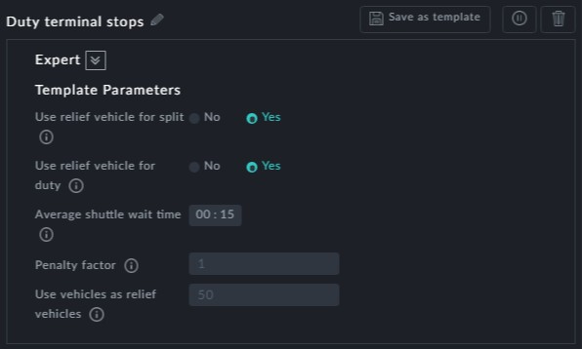

**Points to note:**

**Use relief vehicle for split**: Setting this to Yes means that a driver may travel from the end point of the first duty piece to his split location or from the split location to the first stop of the second duty piece as a passenger on a relief vehicle



**Use relief vehicle for duty**: Setting this to Yes means that a driver may travel -from the duty start point to the vehicle location or to the duty end point from where he left the vehicle - as a passenger on a relief vehicle.



**Average shuttle wait time**: This is a fixed cost in work hours that is paid for each use of a shuttle vehicle.



**Penalty factor**: This is a factor that multiplies the taxi relief vehicle's distance. It is a penalty for using a taxi.



**Use vehicles as relief vehicles**: This allows conversion of relief trips to deadheads. it does this by imposing a penalty. The higher the penalty, the greater the preference to use a deadhead as the means of a relief trip



There may be only one instance of this preference



***Relief Vehicles***

**Purpose:**

This template differs from the previous one in not having the last field, **Use vehicles as relief vehicles**.

**Prerequisites:** The same as the previous template

**Opening Dialog:**

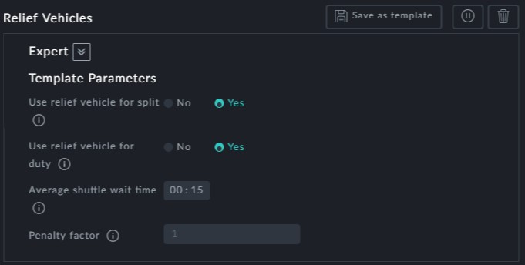

**Points to note:**

This version of the template does not allow conversion of the relief trip to a deadhed.